**Covid19 Projections and Recommendations in Georgia**

Pinar Keskinocak1, PhD; Buse Eylul Oruc1, MSc; Arden Baxter1; John Asplund1,2, PhD; Nicoleta Serban1, PhD

1: School of Industrial and Systems Engineering, and [Center for Health and Humanitarian Systems](http://chhs.gatech.edu/), Georgia Institute of Technology, Atlanta, GA, USA

2: Department of Technology and Mathematics, Dalton State College, Dalton, GA, USA

**Executive Summary**

This report includes projections of new daily infections, deaths, and healthcare resources (hospital beds, ICU beds, and ventilators) for the **State of Georgia**. Our observations and recommendations include:

* Shelter-in-place has a significant impact on temporarily slowing down the disease spread and delaying the peak. However, an important factor affecting the percentage of population infected and the number of infections at the peak is the compliance levels with voluntary quarantine or other physical distancing measures after shelter-in-place ends.
  + Under **voluntary quarantine**, all household members stay home if there is a person experiencing cold- or flu-like symptoms in that household, until the entire household is symptom-free.
* School closures reduce infections and delay the peak; however, school closures alone are not sufficient.
* Our estimates for COVID19-related needs for hospital beds, ICU beds, and ventilators suggest potential shortages across the 14 hospital regions of Georgia, especially under low or medium compliance with physical distancing. These results further emphasize the importance of shelter-in-place and high compliance levels for physical distancing after the end of shelter-in-place.
* It is essential to:
  + continuously communicate to the public the importance of physical distancing.
  + strongly promote voluntary shelter-in-place, voluntary quarantine, and other physical distancing measures.

We are now at a critical juncture. In Georgia, shelter-in-place ensued during April 3-30. Depending on how quickly and widely the public disengages from physical distancing measures in the coming weeks:

* The total number of COVID19-related deaths by August could range from 6,100 to 17,900.
* At the peak, the number of new infections could range from 44,800 to 77,700.
* Demand for hospital beds could range from 12,200 to 26,300, far exceeding the capacity that may be available for COVID19 patients.

**Supplementary Information**

The estimates are based on the results of an agent-based simulation model we developed, to predict the spread of COVID19 geographically and over time. The model helps us understand the impact of the type and duration of physical interventions, as well as the public’s compliance levels. It captures the progression of the disease in an individual and interactions in households, workplaces, schools, and communities. The model incorporates physical distancing interventions, namely school closures, shelter-in-place, isolation of confirmed cases, or voluntary quarantine.

We tested various scenarios *(Figure 1)* of shelter-in-place and voluntary quarantine, with different durations and time-varying compliance levels, utilizing census-tract level data from the state of Georgia.

After the end of shelter-in-place, we considered low, medium, or high compliance levels for voluntary quarantine. In the 4-week shelter-in-place scenarios, the percentage of infected population could range from 28% to 46% and the peak could occur in late June or August, for low and high compliance with voluntary quarantine, respectively.

Delaying and reducing the peak not only reduces the total number of infections and deaths, but also helps reduce the stress on healthcare resources such as hospital beds, ICU beds, and ventilators *(Figure 5)*. While it is highly effective in reducing infection spread, shelter-in-place can be socially and economically disruptive if it remains in place with high levels of compliance for long periods of time. As an alternative, voluntary quarantine is targeted to households with symptomatic individual(s), and hence, the overall percentage of the population staying home at any given time is significantly less under voluntary quarantine, even under high compliance levels, compared to shelter-in-place.

Under voluntary quarantine, household members are advised to stay home if there is a person with cold- or flu-like symptoms in the household (even in the absence of testing or confirmation of COVID19), until the entire household is symptom-free. While high compliance with voluntary quarantine significantly reduce infections, this intervention alone is not sufficient. Some households may have individuals infected with COVID19, and yet all household members might be asymptomatic – voluntary quarantine would not impact such households and they could infect others.

COVID19 poses threats to almost all aspects of human life as we know it, ranging from public health to supply chains and economy to societal interactions. The health and well-being of the population is of utmost importance, but there is also a growing desire to relax physical distancing and go back to a new normal, as the economic and social pressures mount.

As we strive to return to a new normal, *it is important for the public to understand the importance of physical distancing, and for leaders and public health officials to continue strongly promoting voluntary shelter-in-place, voluntary quarantine, and other physical distancing measures, with an emphasis that some people might be infected with little or no symptoms and infect others*. Our collective patience and commitment to continuing physical distancing will save lives and help us return to a healthier and stronger society, which is a foundation for a strong economy.

Figure 1: Scenarios considering 4-week, 5-week, 6-week shelter-in-place followed by low, medium, high compliance with Voluntary Quarantine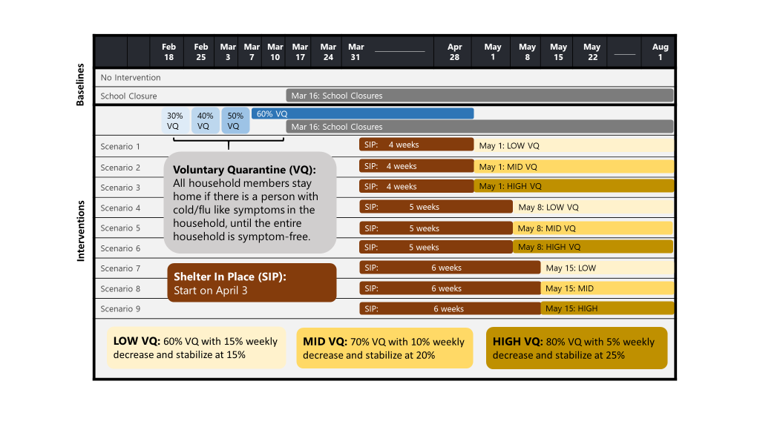

Figure 2: Projected daily new infections in Georgia under different scenarios, including no intervention and school closures only.  
If there had been no intervention, the percentage of the population infected could have exceeded 64%, and the peak would have occurred around mid-April. School closures alone would have reduces this percentage to around 55% and delayed the peak by about a week.

The percentage population infected is projected to further reduce significantly, if shelter-in-place is followed by high compliance with voluntary quarantine and other physical distancing measures.

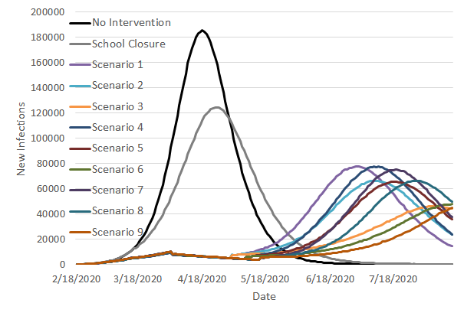

|  |  |  |  |
| --- | --- | --- | --- |
|   4-weeks shelter-in-place, followed by low, medium, high compliance with voluntary quarantine | |   5-weeks shelter-in-place, followed by low, medium, high compliance with voluntary quarantine | |
| Infection spread slows down significantly during shelter-in-place  Low VQ compliance High VQ compliance  Medium VQ compliance  6-weeks shelter-in-place, followed by low, medium, high compliance with voluntary quarantine | |

Figure 3: Projected daily new infections in Georgia under different scenarios considering 4-, 5-, 6-week shelter-in-place durations and low, medium, high, voluntary quarantine compliance levels after the end of shelter-in-place (zooming into scenarios 1-9 from Figure 2).

Figure 4: Projections for cumulative Covid19-related deaths under different scenarios in Georgia. Figure on the right zooms into the scenarios considering 4-, 5-, 6-week shelter-in-place durations and low, medium, high, voluntary quarantine compliance levels after the end of shelter-in-place. 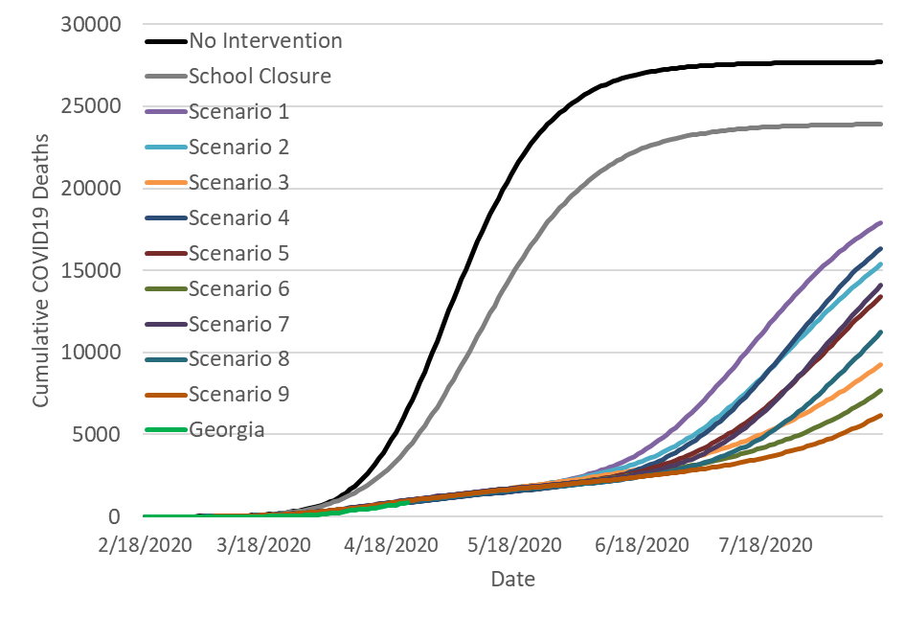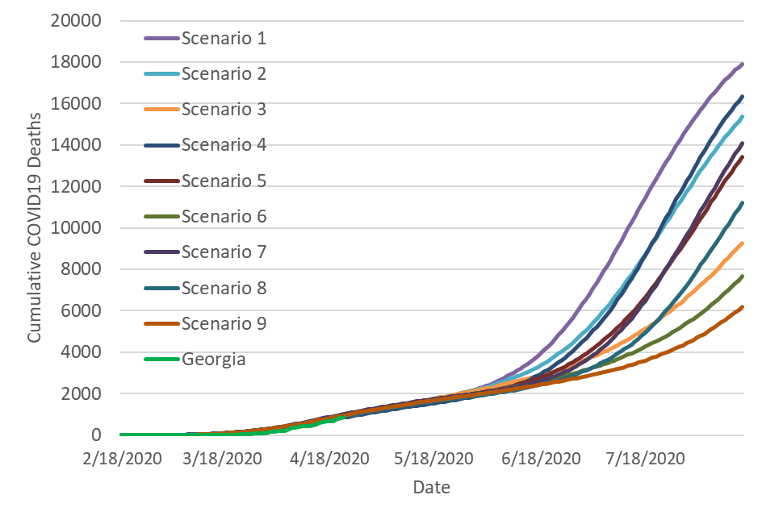

Figure 5: Projected peak demand for Covid19-related hospital beds, ICU beds, and ventilators in the 14 hospital regions of Georgia under 4-weeks shelter-in-place, followed by medium compliance with voluntary quarantine (Scenario 2).

Figure 6: Projected demand for COVID19-related hospital beds (left) and ICU beds (right) in hospital region N under 4-week shelter-in-place, followed by medium compliance with voluntary quarantine (Scenario 2).

Figure 7: Map of the coordinating hospital regions of Georgia.

